**How to resolve issue with Runs and Posts due to Day light Saving**

Some users might face while doing the runs and postings when Day Light Savings time changes. When they will perform any postings or runs the start time of file processing will get delay by an hour.

To avoid these issue, before running the file through "RunFDMProcess" or "Posting Engine," the users must set their system time to UK time.

Local time: UK time:

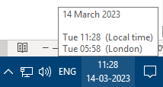

To change the Local time to UK time, follow the below steps :

Step-1 click on time.

Step-2 click on “Date and time settings”.

Later change the time to London time which is shown in below snip:

After changing the time, the users can run the file through “RunFDMProcess” or “Posting Engine.” It will start processing successfully.

**NOTE: Every time the system closes, the local time changes hence the users must switch back to UK time.**